Automated Build, Flash and Debug in CodeWarrior

This document will explain how to automate the building, flashing and debugging of a CodeWarrior project with one “button”.
A batch (.bat) file and a .tcl script will be used.
The .bat file automates the build process and the .tcl script automates the flash programming and launches the debugger.
You must have a CodeWarrior project open with a target that generates an image that can run from Flash.

- Create CodeWarrior project.
- Open a new text file and name it flash_and_debug.tcl
- Add the following commands in the file:
  - cmdwin::config page off --- Turns on command window paging
  - cmdwin::fl::load mcf52233_intflash.xml – this is the Flash Programmer configuration file. I like to have a local copy in your project directory. Copy from {CodeWarrior_Install_Dir}\bin\Plugins\Support\Flash_Programmer\ColdFire to your Project directory.
From here:
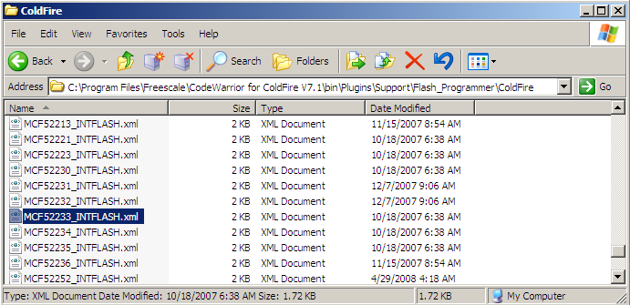

To here:
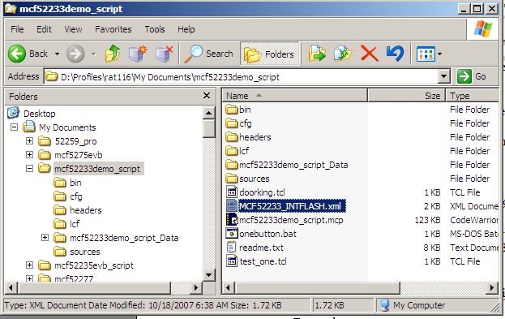

Of course the name of the .xml file and project directory will reflect your project and processor.

  - cmdwin::fl::erase all – Erases all of flash. Still trying to figure out how to erase individual sectors.
  - cmdwin::fl::write – Programs the flash with the default .elf file from the project you have open.
  - debug – Launches the debugger

- Save the file into your project directory.
- Open a new text file and call it build.bat.
- In this file add the following:
  - cmdide /b ---- This issues the build command to the open project
  - cmdide /d flash_and_debug.tcl --- This runs the debug script from the Command Window in CodeWarrior
- Save this file to your project directory.
- To launch the .bat file we will create a new menu item and command:

  - From CodeWarrior open the Command and Key Bindings window
(Edit->Commands and Key Bindings….)

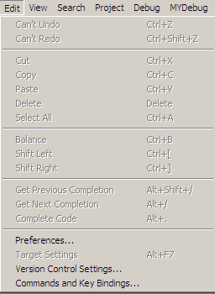

  - Select New Group and call it Build Flash and Debug
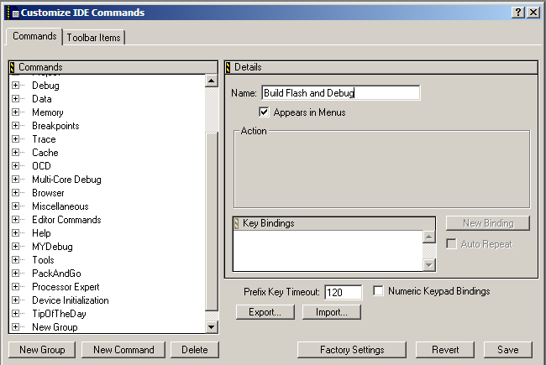

  - Select New Command and call it Execute Script.
  - Select the ellipses (…) in the execute box and browse to you project directory and select build.bat
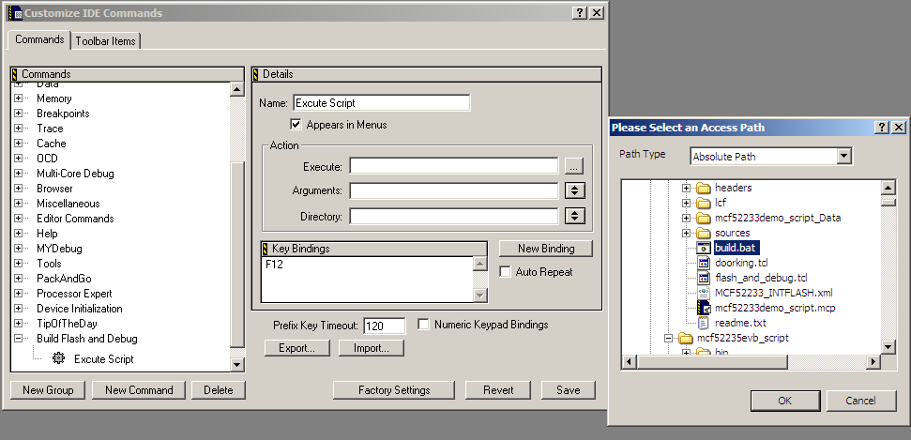

  - Select New Binding and assign F12.
  - Save and close the this window, you should now have a new Menu item called
“Build Flash and Debug”

- Ensure you are connected to your target and from CodeWarrior select
Build Flash and Debug->Execute. Or press F12. This should build you target,
launch the Command Window, erase and program flash.

- You should see the following window if successful:
